Contributors
- Şevda Yağmur Asal
- Oğuz Giray Bori
- Deren Berk
- Mert Dönmez

1. System Overview
Brief Project Description
Dizi Kutusu is a web-based series tracking and review platform. Users can register, log in, search for TV series, rate them, write reviews, and maintain a personal watchlist. The main goal is to provide a structured environment where users can manage and share their viewing experiences.
System Architecture
The system follows a Layered Architecture:
- Presentation Layer (Frontend – HTML/CSS/JS)
- Application Layer (Flask routes & services)
- Data Layer (SQLite + SQLAlchemy)
Architecture Type:
Monolithic modular backend with separated components.
Technology Stack
Frontend:
- HTML
- CSS
- JavaScript
Backend:
- Python
- Flask
- SQLAlchemy

Database:
- SQLite
Testing:
- Pytest
Version Control:
- GitHub
2. Implementation Details
Codebase Structure
dizi_kutusu/
│
├── app/
│ ├── routes/
│ ├── models/
│ ├── services/
│ ├── auth/
│ ├── templates/
│ └── static/
│
├── tests/
├── config.py
├── run.py
└── requirements.txt
Key Implementations
1. Authentication Module
Handles:
- User registration
- Login
- Logout

2. Series Module
Handles:
- Add series
- Search series
- View details
3. Rating & Review Module
Handles:
- Add rating (1–5)
- Add review
- Calculate average rating

Component Interfaces
Example Model
class User(db.Model):
id = db.Column(db.Integer, primary_key=True)
username = db.Column(db.String(50))
email = db.Column(db.String(100))
password_hash = db.Column(db.String(200))

Auth Component
Input:
- email (string)
- password (string)
Output:
- success (boolean)
- session object

Series Component
Input:
- title (string)
- genre (string)
- description (string)
Output:
- series object
- success status
Review Component
Input:
- rating (integer 1–5)
- review_text (string)
Output:
- updated average rating
- success status

Example API Endpoints
Method | Endpoint | Description
POST | /register | Register user
POST | /login | Login user
GET | /series | List or search series
GET | /series/<id> | View series details
POST | /series | Add new series
POST | /series/<id>/rate | Add rating
POST | /series/<id>/review | Add review

Visual Interfaces
- Login Page
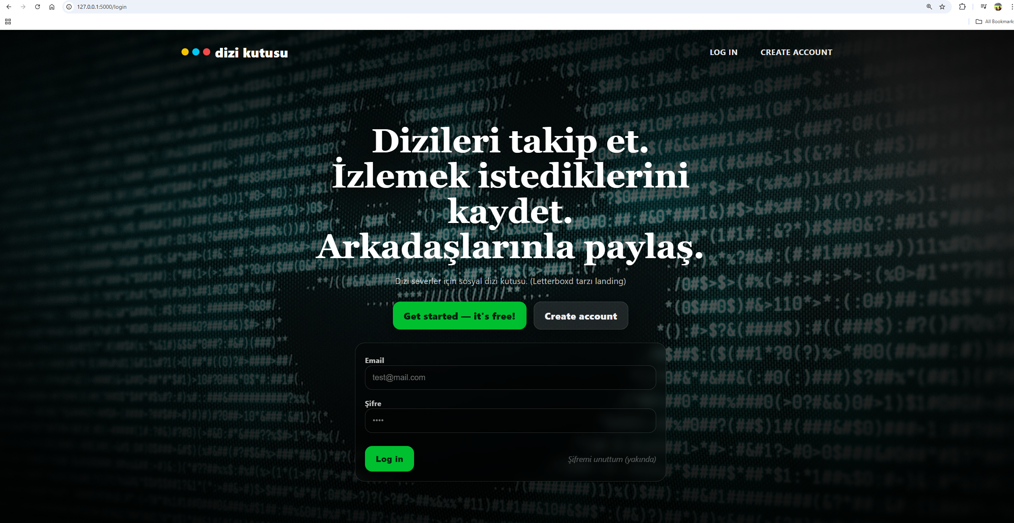

- Signup Page
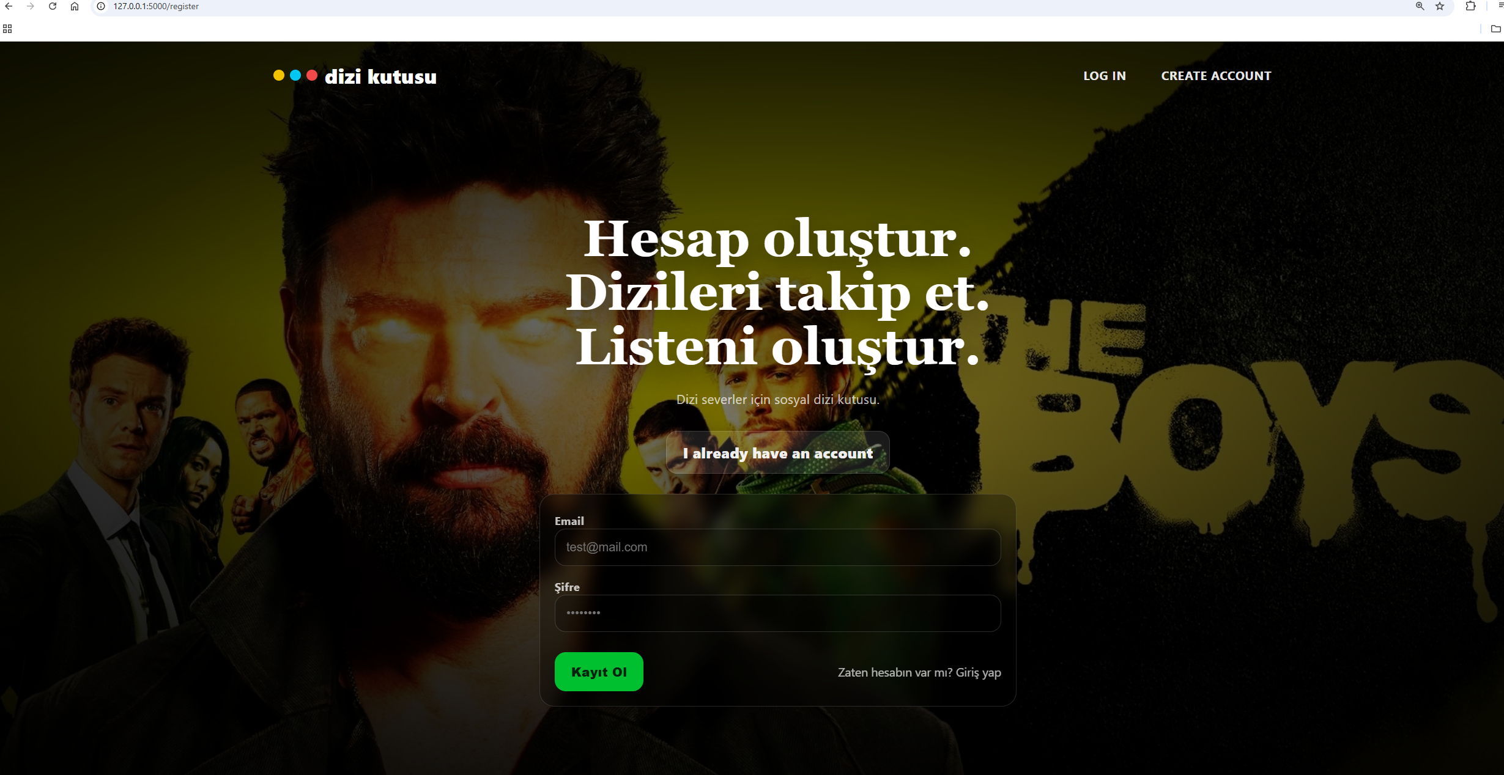
- Dashboard
- Series Detail Page
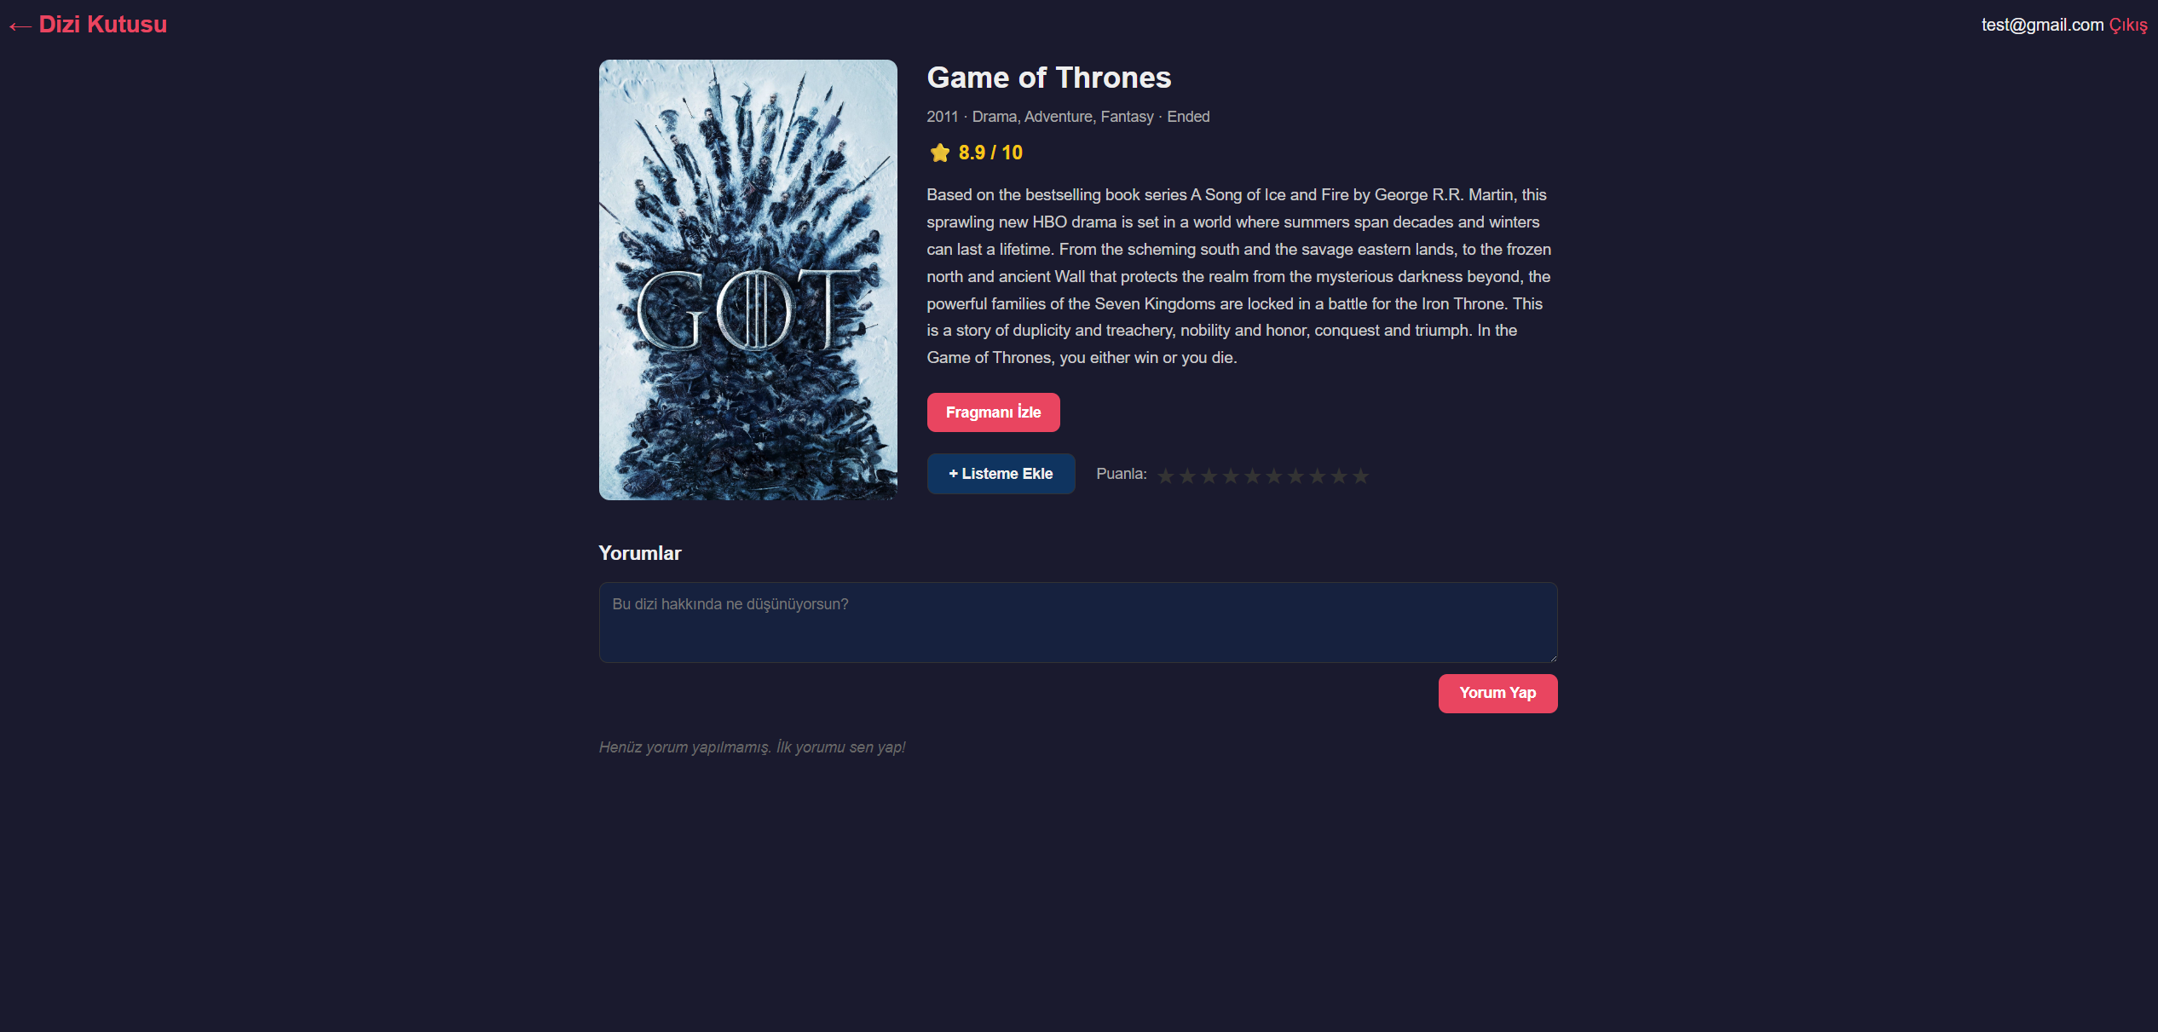

- Profile Page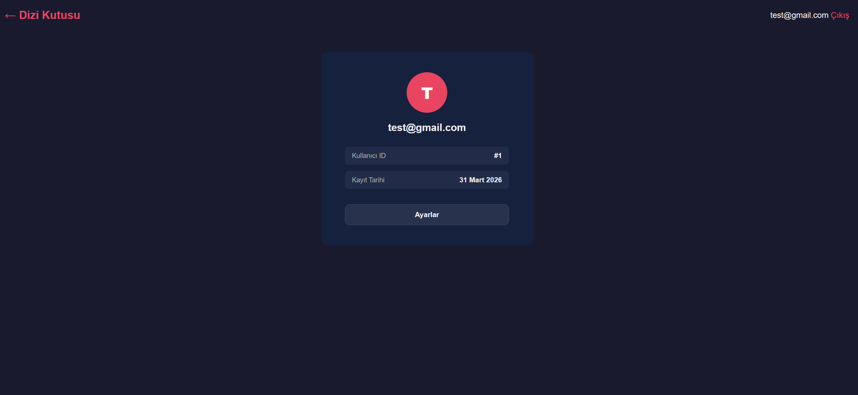

(screenshot will be changed )

3. Use Case Support in Design
USE CASE 1 — User Authentication

Related Functional Requirements
FR1: The user must be able to create an account by providing username, email, and password.
FR2: The user must be able to log in using email and password.
Architectural Support
Presentation Layer
- register.html
- login.html
- POST /register
- POST /login
Application Layer
- auth_service.py → register_user()
- auth_service.py → authenticate_user()
Data Layer
- User model
- SQLite database
- Session handling
Data Flow
- The user opens the registration or login page.
- The user submits the required credentials.
- The Flask route receives the request.
- For registration, the system validates input and creates a new user record.
- For login, the system retrieves the user by email.
- The password hash is verified.
- If valid, a session is created.
- The user is redirected to the main page.
State Changes
Before:
- User may not exist in database
- No active session
After:
- New user may be added to database
- Session created after successful login
- User state = authenticated
Module Interaction
templates/register.html / templates/login.html
↓
routes/auth_routes.py
↓
services/auth_service.py
↓
models/user.py
↓
SQLite Database / Session Manager

USE CASE 2 — Add Series
Related Functional Requirement
FR3: The user must be able to add a new series with title, genre, and description.
Architectural Support
Presentation Layer
- add_series.html
- POST /series
Application Layer
- series_service.py → create_series()
Data Layer
- Series model
- SQLite database
Data Flow
- An authenticated user opens the Add Series page.
- The user fills in title, genre, and description.
- The form sends a POST request to /series.
- The backend validates the submitted data.
- The service layer creates a new Series object.
- SQLAlchemy stores the series in SQLite.
- A confirmation message is returned.
State Changes
Before:
- Series does not exist in database
After:
- New row inserted into series table
Module Interaction
templates/add_series.html
↓
routes/series_routes.py
↓
services/series_service.py
↓
models/series.py
↓
SQLite Database

USE CASE 3 — Search and View Series
Related Functional Requirement
FR4: The user must be able to search for series and view their details.
Architectural Support
Presentation Layer
- search bar on dashboard
- series_list.html
- series_detail.html
- GET /series
- GET /series/<id>
Application Layer
- series_service.py → search_series()
- series_service.py → get_series_details()
Data Layer
- Series model
- SQLite database
Data Flow
- The user enters a keyword in the search field.
- A request is sent to the backend.
- The backend queries the database for matching series.
- Matching results are returned and displayed.
- The user selects one series from the list.
- The backend retrieves the selected series details.
- The detail page is rendered.
State Changes
Before:
- Series data exists but is not yet displayed to the user
After:
- Matching series list shown
- Selected series details displayed
Module Interaction
templates/series_list.html / templates/series_detail.html
↓
routes/series_routes.py
↓
services/series_service.py
↓
models/series.py
↓
SQLite Database

USE CASE 4 — Rate and Review Series
Related Functional Requirements
FR5: The user must rate a series between 1–5.
FR6: The user must be able to write a review for a series.
Architectural Support
Presentation Layer
- series_detail.html
- POST /series/<id>/rate
- POST /series/<id>/review
Application Layer
- review_service.py → add_rating()
- review_service.py → add_review()
- review_service.py → update_average_rating()
Data Layer
- Rating model
- Review model
- Series model
- SQLite database
Data Flow
- The user opens the detail page of a series.
- The user selects a rating and writes a review.
- The form sends the request to the backend.
- The backend validates the rating range and review input.
- A Rating object and Review object are created.
- The average rating of the series is recalculated.
- Changes are committed to the database.
- The updated detail page is shown.
State Changes
Before:
- No rating/review from this user for the selected series
After:
- New rating row inserted
- New review row inserted
- Series average rating updated
Module Interaction
templates/series_detail.html
↓
routes/review_routes.py
↓
services/review_service.py
↓
models/rating.py / models/review.py / models/series.py
↓
SQLite Database

Architecture Summary for All Use Cases
All 4 use cases follow:
Presentation Layer
→ Route Layer
→ Service Layer
→ Model Layer
→ Database
This ensures:
- Separation of concerns
- Testability
- Modularity
- Maintainability

4. Design Decisions
Technology Comparison
Flask vs Django
Feature | Flask | Django
Flexibility | High | Medium
Built-in Features | Low | High
Learning curve | Easier | Hard

Decision: Flask chosen for flexibility and modular structure.

MySQL vs SQLite
Feature | MySQL | SQLite
Scalability | High | Low
Multi-user support | Yes | Limited
Setup Complexity | High | Low
Performance (small apps) | Medium | High
Decision: SQLite chosen for simplicity and ease of setup.
SQLite was selected because the project is a small to medium-scale web application. It does not require complex database configuration, making development and testing faster. SQLAlchemy is used as an ORM to manage database interactions efficiently.
5.Design Patterns and Architectural Designs
5.1 Factory Patterns
Problem:
The project requires a structured and reusable way to initialize the application, configure extensions, and register routes. If these responsibilities are handled in a single global application object, the code becomes harder to test and maintain.
Factory Pattern
Where it is Used:
The Factory Pattern is applied in the application initialization process through the create_app() function in app/__init__.py. This function is responsible for creating the Flask application instance, loading configuration settings, initializing SQLAlchemy, and registering blueprints.
Architectural Role:
The pattern is used at the application setup level. It separates object creation from object usage and allows the system to create application instances in a controlled and reusable manner.
Design Decision:
Factory Pattern was selected because the project uses a modular Flask structure and benefits from flexible application creation. It also supports easier testing by allowing separate app instances for development and test environments.
Quality Factors and Criteria:
- Maintainability: application setup logic is centralized in one place
- Testability: separate app instances can be created for automated tests
- Modularity: blueprints and extensions are registered in a clean structure
- Configurability: different configuration modes can be supported more easily

5.2 Singleton Patterns
Problem:
The project requires a shared and consistent database access object throughout the application. If multiple database manager objects were created independently in different modules, configuration and state management would become harder to maintain.
Chosen Pattern:
Singleton Pattern (framework-supported / singleton-like usage)
Where it is Used:
The project uses a shared SQLAlchemy object defined in app/db.py as:
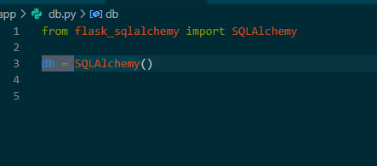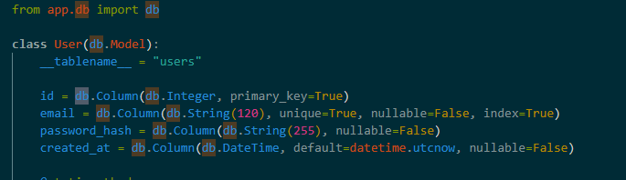
This object is imported and reused across the application modules. Due to Python’s module loading mechanism, the same db object is shared wherever it is imported. This creates singleton-like behavior, since the application works with one common database interface instead of multiple separate database objects.

Architectural Role:
This pattern appears in the data access and infrastructure layer. The shared db object acts as the central database interface for models and persistence operations.

Design Decision:
A shared database object was preferred to ensure consistency, simplify configuration, and avoid repeated initialization of database access components. Since Flask-SQLAlchemy is already designed around centralized extension initialization, this approach fits naturally into the project architecture.

Quality Factors and Criteria:
- Maintainability: database configuration is centralized in one place
- Consistency: all models and services use the same database interface
- Simplicity: avoids repeated database object creation in different modules
- Reliability: reduces the risk of configuration mismatch across components

5.3 Architectural Designs
The UML diagrams of the system were updated to reflect the integration of design patterns into the architecture.

For the Factory Pattern, an AppFactory component (create_app function) was introduced into the class diagram. Instead of directly creating the Flask application instance inside routes or tests, the system now requests an application instance from the factory. This change redirected dependencies toward the factory component, improving modularity.

For the Singleton Pattern, the shared database object (db = SQLAlchemy()) was represented as a single centralized instance in the class diagram. All models such as User and Series depend on this shared database object, which is accessed through imports. This reflects singleton-like behavior.

In the sequence diagram, object creation was updated to include the factory process. Instead of directly initializing the application, the actor (e.g., test or user request) sends a message to create_app(config). The configured application instance is returned and then used in the execution flow.

5.4 Design Decisions and Trade-offs
The design decisions were made by evaluating alternative approaches for managing application configuration and testing.
Problem:
How to run the system in both development and testing environments without affecting real data, and how to avoid hard-coded configurations.
Alternative 1:
Using a single global Flask instance with hard-coded database configuration. This approach was rejected because it reduces flexibility and makes testing difficult.
Alternative 2 (Chosen Solution):
Using the Factory Pattern through the create_app(config) function. This allows the application to be created with different configurations (e.g., test database, production database).
Decision Rationale:
Although the Factory Pattern introduces a slight increase in architectural complexity, it significantly improves flexibility and testability. It allows isolated application instances to be created for testing, preventing interference with production data.

5.5 Quality Factors and Design Pattern Impact
The selected design patterns contribute directly to key software quality attributes:
Testability:
The Factory Pattern allows the creation of separate application instances with different configurations. This enables the use of test databases and ensures that automated tests do not affect real data.

Maintainability:
The use of modular architecture (Flask Blueprints and separation of layers) improves maintainability. Changes in one module (e.g., authentication) do not affect other components.

Reusability:
Decorator-based structures (such as Flask routes and pytest fixtures) allow reusable logic across multiple parts of the application, reducing code duplication.

Performance and Resource Utilization:
The Singleton-like usage of the database object ensures that only one database interface is used across the system. This prevents redundant connections and reduces memory overhead.

6. GitHub Commit Requirement
https://github.com/mertdonmez1453/dizi-kutusu.git
All code implementations, interface definitions, and UI designs are uploaded to the GitHub repository.

Each team member contributed through commits, and version history clearly reflects individual contributions.

The repository also includes code snippets used in technology comparison and testing.

7. Task Matrix
Task | Responsible Team Member
System Overview | Şevda Yağmur Asal+ Mert Dönmez
Implementation Details | Oğuz Giray Bori
Objectives & Scope Definition | Deren Berk
Key Features & Target Audience | Mert Donmez
Risks and Mitigation Strategies | Şevda Yağmur Asal
Design Decisions | Oğuz Giray Bori
Testing & QA Plan | Deren Berk
Final Review & Editing | Tüm Ekip

